
Project name: TSR 3.0
Names of project members:
Anton POLTORADNEV (electronics engineer);
Vladimir KOVALEV (head mechanical engineer);
Alexey KIM (head mechanical engineer);
Anastasia CHETINA (parachute developing);
Alena DEMINA (parachute developing);
Roman DAVYDOV (mechanical engineer);
Artem PECHKIN (mechanical engineer);
Alexander BORMINSKY (mechanical engineer);
Ivan TOKAREV (programmer).
Club name: RocketLAV
Year of project launch: 2019
Summary:
At the moment the project of the two-stage TSR 3.0 rocket is the most serious in RocketLAV. This experimental rocket was developed by students of the 3rd course for C’Space 2019 action. The project of previous year - TSR 2.0 has been taken as basis. Our team has considered all defects of last year and taking into account them the following improvements have been brought: more powerful engine for the first stage has been taken, the rigidity of design is improved, the new system of separation is applied, stability of rocket is increased and also the onboard system is improved.
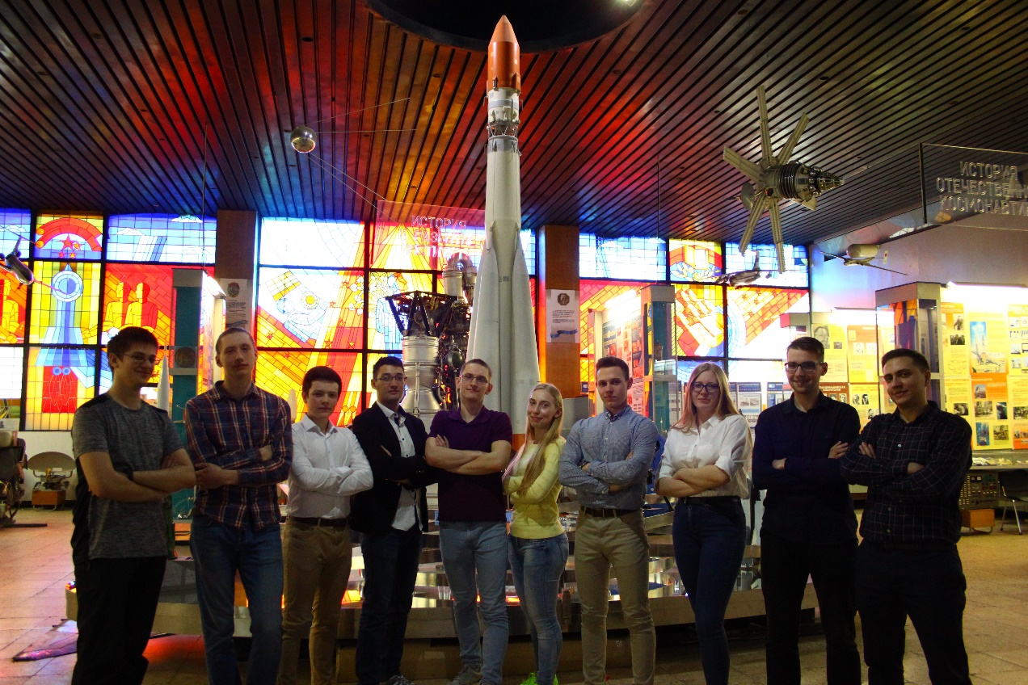
1 Introduction
The idea of creating a two-stage rocket came to us in 2016. And over the next years we confidently walked towards this. In 2019, we are introducing the TSR 3.0 project, which is a continuation of the previous TSR 2.0 project. Given the mistakes of previous years, the supporting structure was reworked, the electronic component was improved, and a more powerful engine was installed on the first stage.
Task of our project – to increase flight altitude of rocket and to successfully launch two. As results of the project the research group submits the report on the done work with the indication of results and conclusions.
2 Mechanical description
Stages of rocket are made of fiberglass parts and metal part.
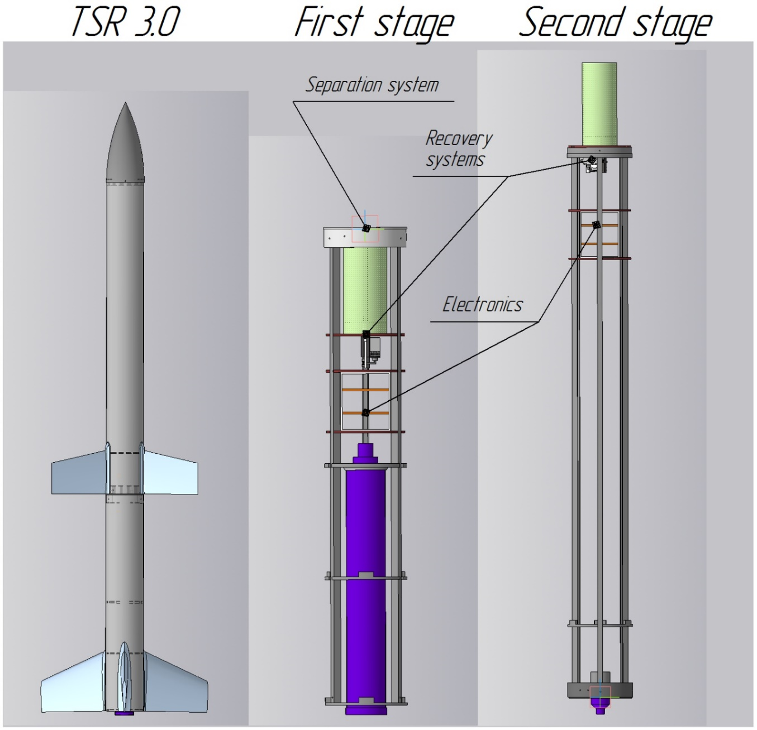
Picture 1 – External structure of the rocket. Internal structure of the both stages
The internal structure of both stages contains a propulsion unit for solid propellant rocket engines Pro75-3G and Cariacou, parachute and electronic compartments. All this construction is bonded top and bottom frames and aluminum profiles, and this makes the construction related and also allows assembling and dismantling a model rocket in short time constraints. The weight of the first stage design is 3.8 kg and the weight of the second stage design is 6 kg.
The actual dimensions and parameters of the rocket are shown in picture 2.
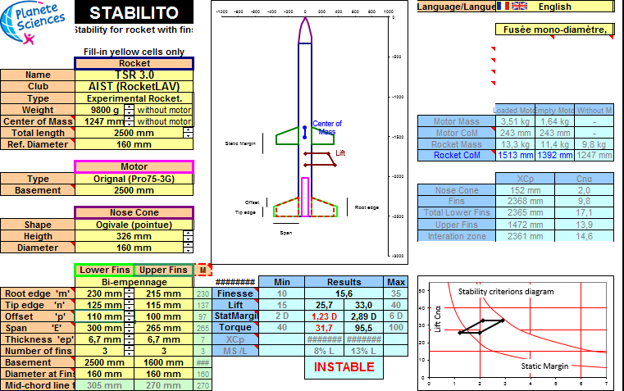
Picture 2 – Screenshot from StabTraj
Fins comprise fiberglass TS-26P (used resin ethane-370). The stabilizer profile NAСA-0012 (picture below).
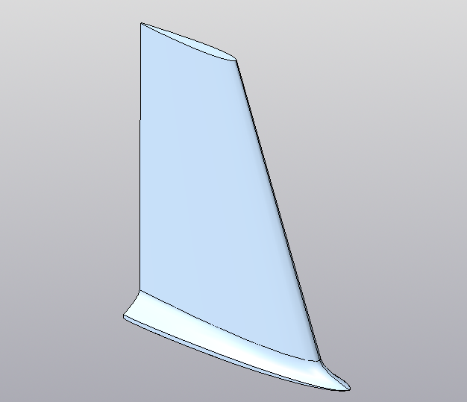
Picture 3 – Fin of the first stage
The recovery system is a container with a latch mechanism.
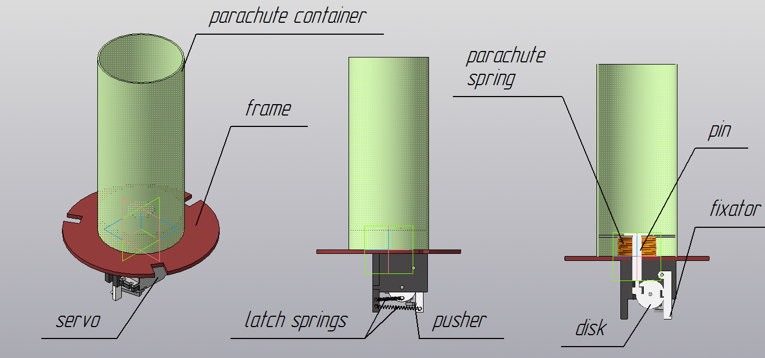
Picture 4 – Recovery system
The servo sets in motion pusher, and the pusher presses on fixator. Disc begins to rotate under the action of latch spring and releases the parachute spring. Parachute is in container and after activation recovery system parachute is deployed in atmosphere.
All electronics of rocket are in container which made from a polystyrene.
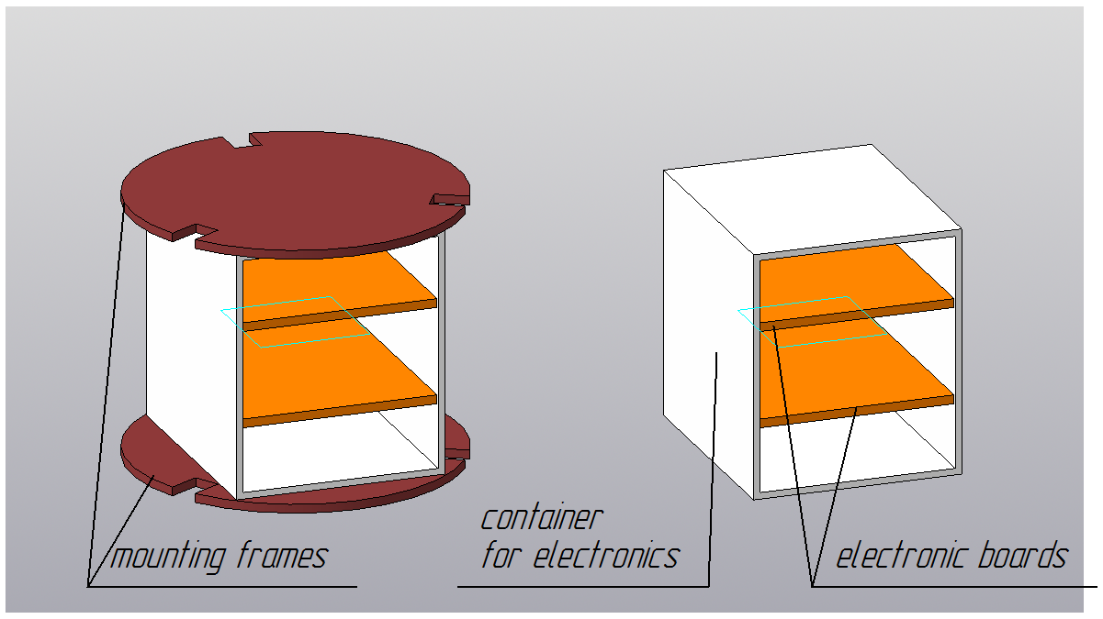
Picture 5 – Electronics
An innovation compared to last year's rocket is the ability to extract the electronics container from the rocket for more convenient work.
The stage separation system uses the principle developed for the previous model of the rocket, but there are new pushers.
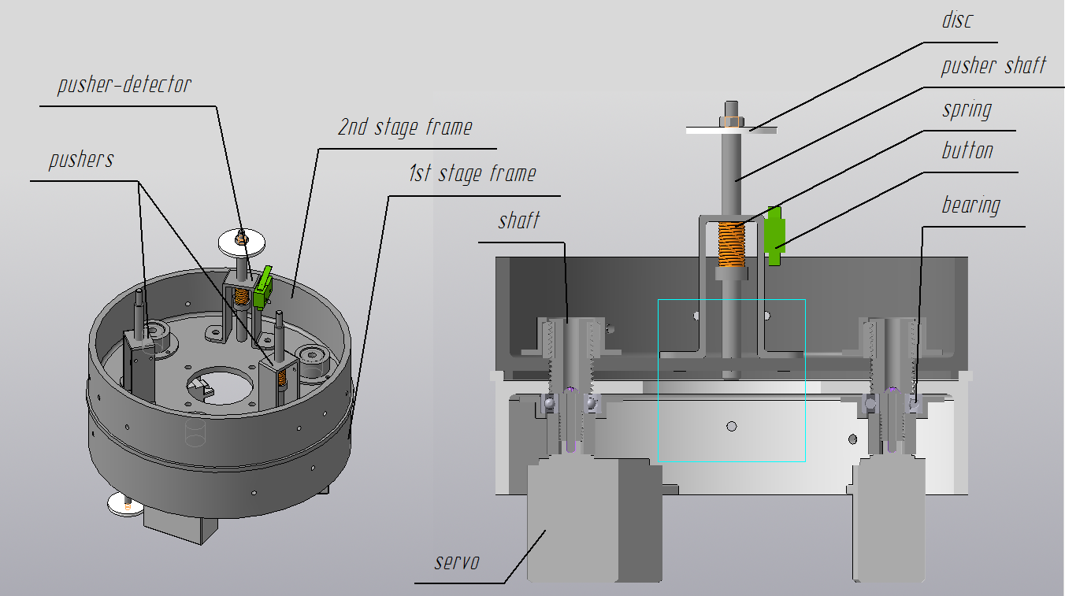
Picture 6 – Separation system
At the required moment servos at the lower stage begin to unscrew the shaft with a thread from the nut fixed on the upper stage of the frames, after which the lower stage departs at the expense of more aerodynamic drag. Pushers help this process. The pusher-detector serves to signal for ignite second stage engine.
3 Electronic and computer description
The onboard electronic system of TSR 3.0 consists of two parts. The onboard electronic system of the first stage and the second. They are completely electric independent of each other, that is, not connected by any kind of connections.
The design of onboard systems of stages is almost the same. The electronics of the first stage includes a telemetry system, a recovery system and a separation system. The electronics of the second stage is a telemetry system, a recovery system and a second stage engine ignition system. Telemetry systems and recovery systems are the same on both stages.
The onboard electronics of the first stage is a cube unit, consisting of 3 boards mounted on top of each other and connected by wires. The faces of the cube are made of dielectric material - polystyrene. On one of the faces of the cube installed working panel for manual control of the onboard system when the rocket is assembled. The onboard electronic system of the first stage includes:
- Power board, DC stabilizers are to power servos, sensors and microcontrollers;
- Electronic board for two STM32F103 microcontrollers to control the recovery and separation system and for telemetry;
- Electronic board of sensors;
- 4000mah 2s LIPO battery for long-term power of modules;
- 1800mah 2s LIPO battery for powering servos.
A jumper is used to detect rocket launch, which during a launch is detached from the rocket, thereby opening contacts and signaling a launch. The separation system is activated after the condition {T_{Start} + T₀} is true, where T₀ is the burnout time of the PRO75 engine. The separation detectors, which are limit switches, monitor the state of separation and, if the stages are separated, then at a pre-calculated time T₁, the first stage recovery system is activated. Otherwise, the recovery system does not work (the stages are not separated), then priority is for the second-stage recovery system. The STM32F103 microcontroller has several independent timers that count down the time from the start, which is necessary to calculate the separation and recovery conditions.
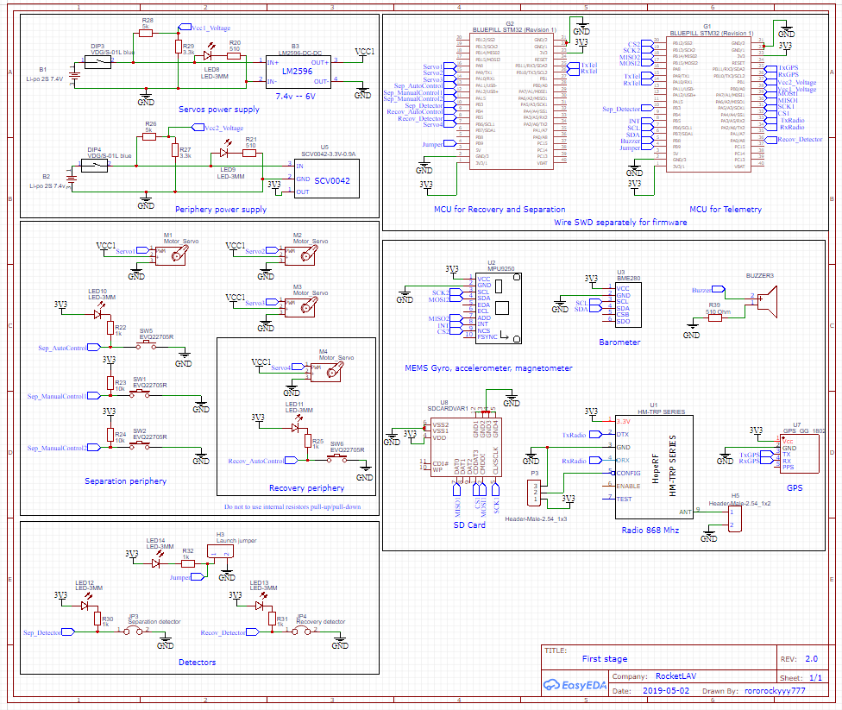
Picture 7 – Schematic of electronics of the first stage

Sensors for the telemetry system:
Atmospheric pressure and temperature sensor - BMP280.
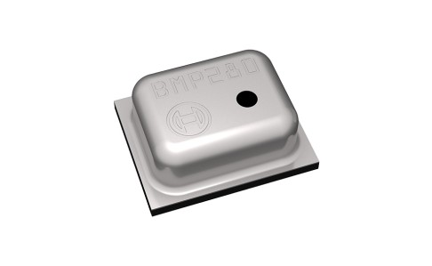
Picture 8 – BMP280

MEMS IMU MPU9250 - linear acceleration sensor, angular velocity and magnetometer.

Picture 9 – MPU9250

GPS GG1802 - gps receiver.
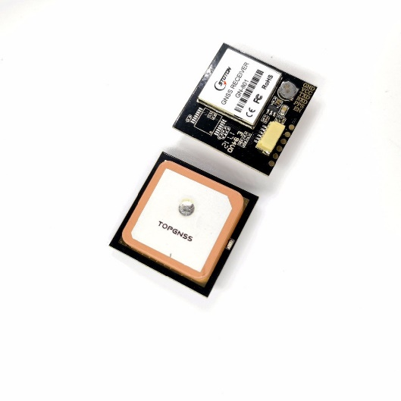
Picture 10 – GPS

To save the data, a microSD is used. For data transmission, a radio module 3DRadio Telemetry is used at a frequency of 868Mhz.
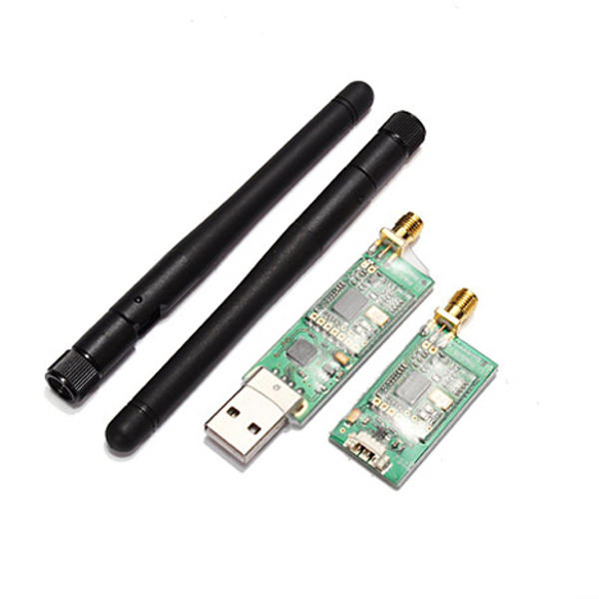
Picture 11 – Radio module

The onboard system of the second stage is similar to the first one, except of an independent module, the engine ignition system of the second stage and the absence of a separatuin system. The second stage telemetry system completely repeats the first telemetry system with the exception of the radio module. The second stage has Mbee-868.2.0 with a frequency of 868 MHz.
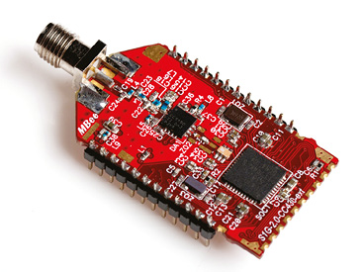
Picture 12 – Radio module of second stage

The onboard electronics of the second stage is also a cube module consisting of 4 boards mounted on top of each other and connected by wires. The faces of the cube are made of dielectric material - polystyrene. On one of the faces of the cube installed working panel for manual control of the onboard system when the rocket is assembled. The onboard electronic system of the first stage consists:
- Power board, DC stabilizers are to power servo, sensors and microcontrollers;
- Electronic board for two STM32F103 microcontrollers to control the recovery and for telemetry;
- Electronic board of sensors;
- Electronic board of ignition system;
- 4000mah 2s LIPO battery for long-term power of modules;
- 2000mah 2s LIPO battery for powering modules of ignition system;
- 1000mah 2s LIPO battery for powering igniter;
- 1800mah 2s LIPO battery for powering servos.
The conditions for launch the second stage engine are:
• stages are separated (limit switch registers it);
• time interval [T_{start} + T₀; T_{start} + T₀ + T_{Window}] sec (arduino timers);
• the stage is in the correct position. Azimuth angle interval [-45 °; + 45 °] and inclination angle [-10 °; + 10 °]. (stm32f103 and MEMS IMU MPU9250 are used for it).
If the condition is true, the register device generates a high level signal and switches the relay. If the three relays are switched, the buzzer will start beeping, indicating that three conditions have been fulfilled, and the engine of the second stage launch. If at least one of the conditions was not fulfilled, the engine start command is not generated.
The recovery system includes three options for implementation:
- If the stages are not separated, the recovery system activate if the condition T> T_{2a} is fulfilled, where T_{2a} is the rocket apogee time in the case of the two-stage variant of flight.
- If the stages are not separated and the launch did not occur, then the recovery system activate if the condition T> T_{2b} is fulfilled, where T_{2b} is the apogee time of the second rocket stage flight
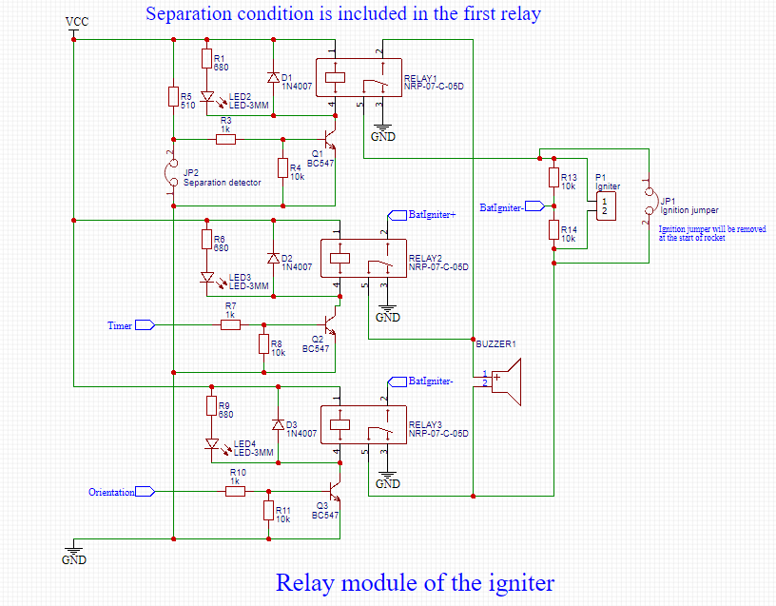
- If the stages are separated and the launch has occurred, then the recovery system activate if the condition T> T_{2c} is fulfilled, where T_{2c} is the apogee time of the second rocket stage with a used second stage engine.

Picture 13 – Relay module of second stage
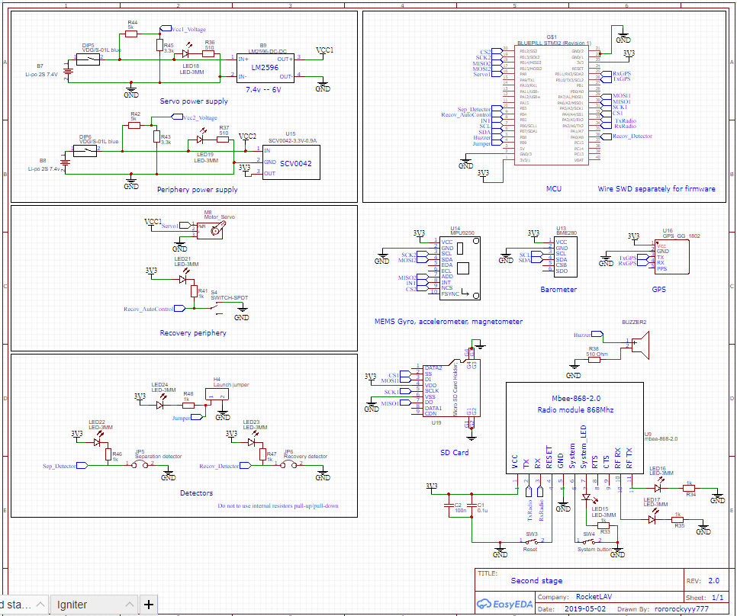
Picture 14 – Schematic of electronics of the second stage

4 Experience
- Expériences réalisées Collecting, saving and analyzing rocket parameters
during the flight. We are going to save data which contains values of linear and
angular acceleration, pressure values, GPS data, ballistic height and distance. For which will be used barometer, accelerometer, magnetometer, gyroscope, installed in the instrument compartment on the board with electronics.
After flight this data are processed and used to refine the mathematical model of
the TSR flight.
Testing separation system of rocket stages in flight and a rescue system mechanism, organization of data
transmission using radio channel over long distances.
- En quoi votre expérience nécessite-elle la mise en œuvre d’une fusex ? To
provide our experiments, sufficient internal placement inside the rocket is
necessary. Also, use of more powerful motors, which available for Fusex projects, allows us to collect more data during the flight.
- Quelle est la méthode d’exploitation des résultats post-vol ? We are going to
use accumulated experience and knowledge, examples of the implementation of
telemetry system, separation system and recovery system in creating a flagship
project – rocket project up to 10 km.
5 Flight sequence
- Launch day - 07/18/2019, 11:30 a.m. The weather left much to be desired, it was very cold and a strong fog. At an altitude of 500-600 meters from the ground, the rocket isn’t seen anymore. The rocket landed in a corn field and one of the stage could not be found.
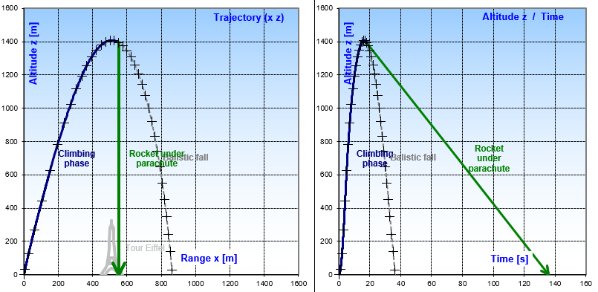
Picture 15 – Trajectory
6 Results
-As a result of the launch of TSR 3.0 we managed to find only the second stage, since both of them landed into the cornfield. During the flight, we observed: the first stage landed by parachute, the second stage made a ballistic flight. After flight we got an onboard video, flight data. As a result, all systems of the rocket have worked fine, but on the time of start of the recovery system of second stage parachute touched the launch pin and got some damage. This damaged parachute of second stage could not land rocket with low vertical speed, but it could lower fall velocity to land rocket without big damage. All stages had radio beacons so we could easily find them. But for the first stage we didn't have enough time to recovery it, because for the launch day we could recovery only one stage. For the next day the first stage didn't have enough power to use a radio beacon, the first stage was lost.
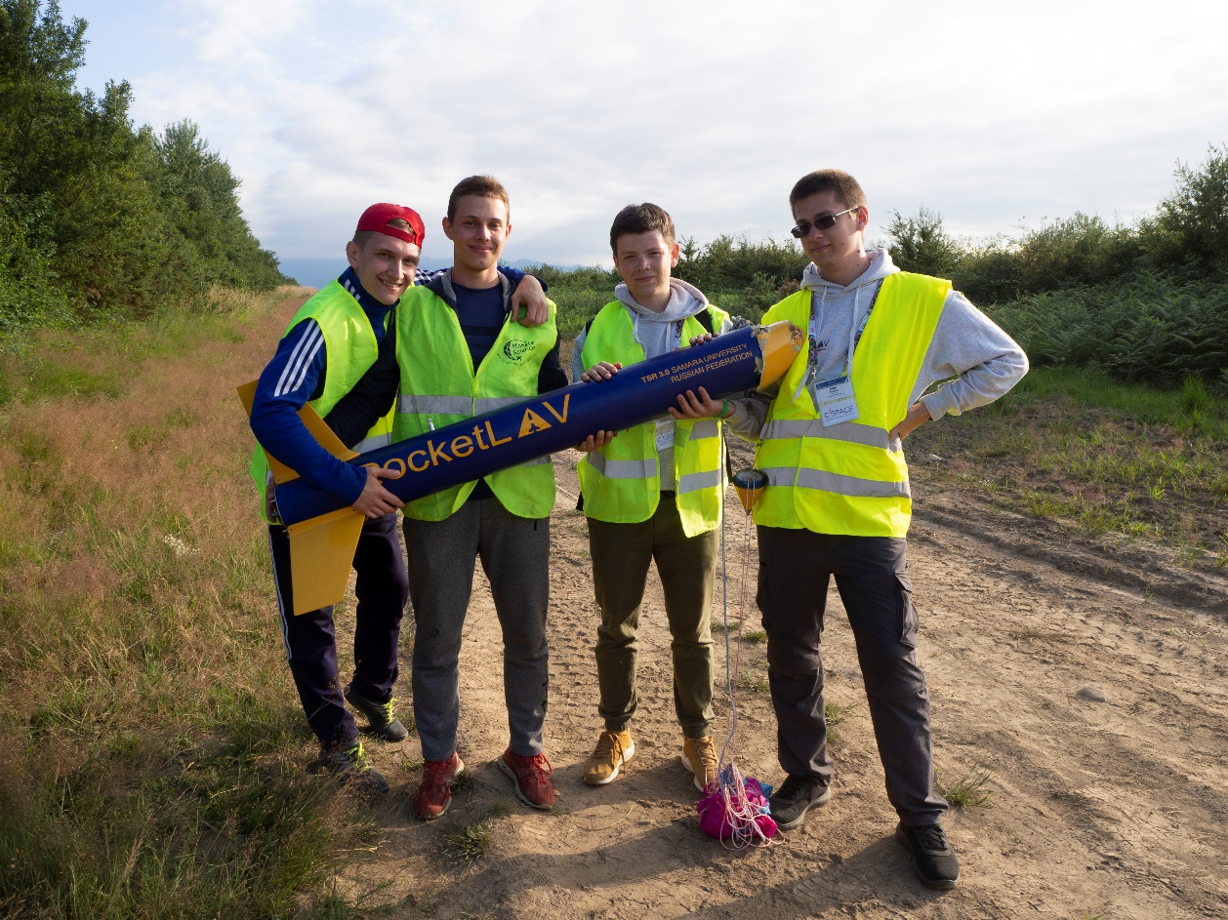
Picture 16 – Found a rocket
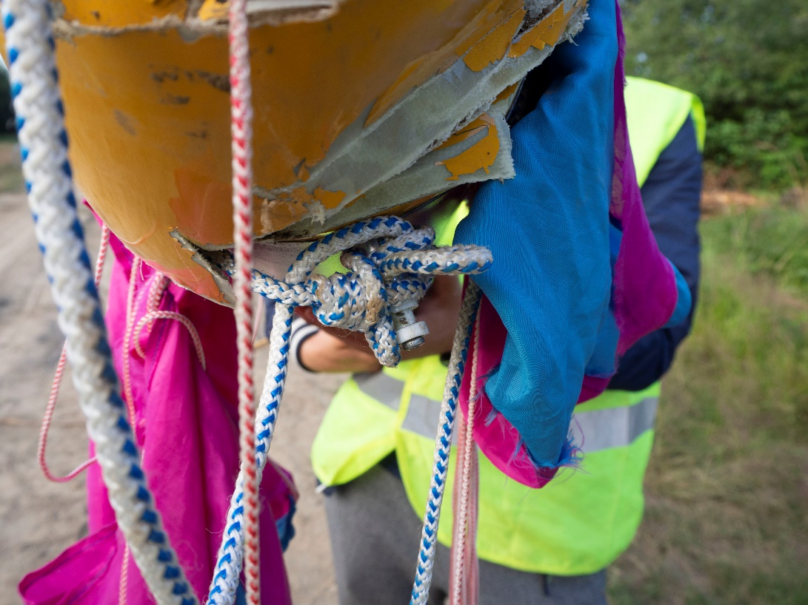
Picture 17 – How the parachute was broken
-The orientation system worked normally and the second stage engine was ignited. We were able to test our developed mechanical systems, which have shown their reliability.
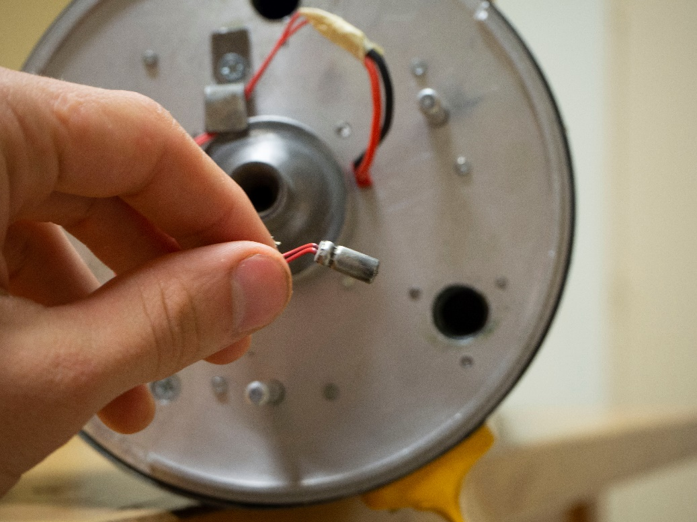
Picture 18 – The igniter
7 Conclusions
-It is worth noting that this year a new team was assembled for the TSR 3.0 project. And now, having passed the “baptism of fire”, the guys are ready to create new projects.
-We managed to test the developed systems: ignition system of second stage, orientation system, separation system, recovery system.
-Because the parachute was broken and the second stage did not land softly, the second stage rescue system was damaged. It was also very difficult for us to lay parachutes, and in the future, we plan to change the operation of the rescue system. For example, apply directional parachute release.
-The separation system worked normally, but with such a system we had very short timings for starting the second stage engine. So, we will update the separation system and reduce the time for separate.
-It is also planned to improve electronics and reduce the number of wires to a minimum.
-In general, the launch was not successful, but all systems worked properly and we first received video from the rocket.
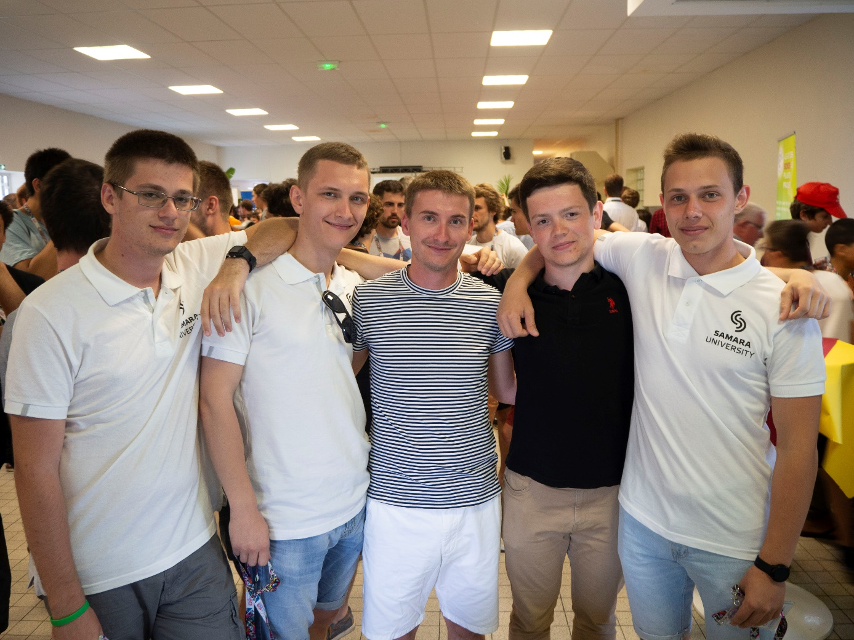
Picture 19 – RocketLAV team with a control Flavien Denis

