Sirius: a CanSat to take atmospheric measures with a guidance system

Ariane Richer, Nassime Chabihi, Ahou Akpoue, Youssef Taleb, Marine Puibaraud

This year, this is the second time the space association of Telecom Sudparis T’Space participates to the CanSat competition. Our current CanSat Sirius is inspired from the previous year’s one with some identical aspects as the possibility of taking atmospheric measures. However, Sirius is smaller and more compact than the previous one, and his structure is completely made of aluminum. The new goal of this year is to succeed in making the CanSat land on a chosen target thanks to a guidance system with a sail.

- Introduction

The CanSat project is a scientific project which aims at creating a space probe. The probe created by students of TELECOM SUDPARIS, is going to realize scientific missions. This technical project is above all for the pupils a learning of the teamwork and an initiation into the project management. But it is also a first experience (experiment) of application of the theoretical knowledge.
As far as missions are concerned:
- Draft air: the CanSat will take a measure of temperature and pressure during its descent and send to the ground by telemetry. The choice of sensors for pressure and temperature will perform this function.
- Mission “comeback”: the GPS coordinates of a target will be given two hours before the competition. The team must find solutions to enable the probe to reach this target. Our team will use a glider to guide CanSat in the air. The forces on the paraglider determine its size.

The team T’Space 2010 TELECOM Sudparis won the encouragement prize of the jury with both probes "Pegasus" and "Chrysaor”. Some team members have traveled to French Guyana as a result of the competition. They have spent one month there. It was a great experience.

- Context of Development

  - Club

Our team is composed of 6 members (see Fig.1), five from the first year and one from the second year in TELECOM SUDPARIS. We are all members of the space club “ T'SPACE “. Some students created this club in 2009. They like space-related things. So they wanted to have an association where they could discuss and take part together to space events. So, this is the second time, our team takes part to the C'SPACE. We do not have a lot of activities. We focus on this competition, and this year, we have received money from other associations of our school.
To carry out this project, different clusters have been defined:
    - Head Risk Management: Emilien KOFMAN
Team member CanSat 2010, he participated in the adventure this year. He also works course structure on electronics. His advice predict major risks during the competition to obtain a probe solid and functional.
    - Relations manager and corporate website: Ahou Akpoue
She is responsible for communication with business and runs the website. She works also on the probe's structure. She has made modelisation with SolidWorks to see the probe before machine finishing.
    - Head and mechanical structure CanSat: Nassime CHAHIBI
It ensures the rigidity of the structure of CanSat. It therefore performs simulations using Solidworks. It handles the strategic arrangement within the probe so that everything is solid and optimized.
    - Head paragliding: Ariane RICHER
She implements solutions for the probe actually reaches its target. Her post consists in controlling the actuator based on the GPS position of the probe.
    - Electronics Leaders: Marine PUIBARAUD and Youssef TALEB
They carry all the schematics using EAGLE software. They maintain the sensor temperature and pressure. They also carry electronic cards to be used in the probe.

One important thing is that each member works not in his field. We work together on some parts together.

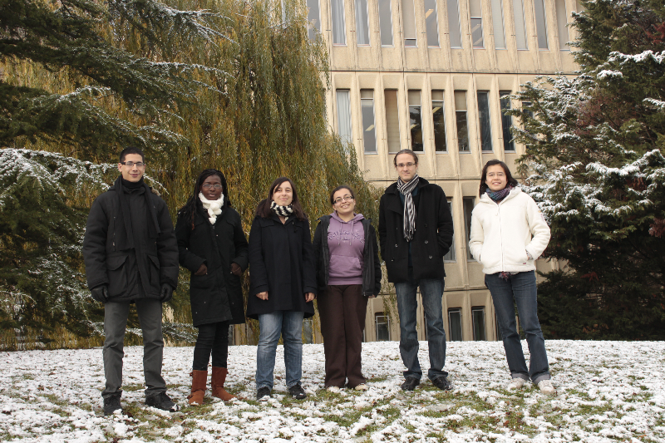

Fig. 1 Picture of the T’Space 2011 team.

  - Work Plan

As the team is composed of six members, a specific task was assigned to each person. Here is the current table which sums up the tasks:

Table I. Posts of the team

Name | Responsibility
Nassime CHAHIBI | Mechanical parts and structure
Ariane RICHER | Paraglide
Ahou AKPOUE | Communication
Youssef TALEB | Sensors and GPS
Emilien KOFMAN | Electronics
Marine PUIBARAUD | Project manager

In fact, the posts changed during the realization, and they are still changing. For instance, at the end of the year 2010, we were not sure about the use of a paraglide, because it depended on the choice of our scientific missions. In spite of this share, we all worked on something different from our specific task. Besides, we didn’t deal with all the tasks at the same time.

The design was the first step of the project which took 3 months (October, November, December): we had to choose the missions our CanSat would perform. This project was above all a school project, we also designed our logos and asked companies and the town council for some aids, because the school didn’t help us at all, except our tutor Mrs. Josephine KOHLENBERG who gave some aids to the previous team CanSat 2010. Except Emilien who participated to the competition last year, nobody had real technical knowledge, that is why, Emilien taught us some aspects of electronics: how to design a circuit broad for instance.
The fabrication took five months and began in January. Indeed, at first, we all concentrated on the realization of the mechanical structure and the electrical architecture, that is to say, the circuit boards and the sensors. Then, some members dealt with the programmating of the GPS, whereas others took an interest in the realization of the paraglide and telemetry. Then, the tests will take the last months before the competition.

The team was followed by two tutors: Mrs. Josephine KOHLENBERG and Mrs. Corinne LE ROUX the team met once a month and informed with reports. With these meetings, we explained to the tutors our work and it was a way to know if we correctly followed the planning.

As far as the budget is concerned, we could benefit from the remaining budget from the previous team and from the aids from an association of our school, Forum of the Telecommunications. Here is a table which sums up our project budget:

Table II. Budget

Products | Amount | Price (euros)
Aluminum | 250 mm Tube (60mm*70mm)  60mm Bar (60mm*70mm) | 46.17
Pressure Sensor | 3 | 19.95
GPS | 1 | 59.95
Atmega128 | 1 | 42
Contribution for a milling machine (Intech club) |  | 200
Radio-controlled paraglide | 1 | 60
Total |  | 428.07

- Definition of the Missions

Our CanSat is a small autonomous probe that fits in a 33 cL cylinder. It conducts scientific missions such as air or ground surveys, flying toward a target, rolling like a rover and so forth. These missions take place in the atmosphere, in order to escape the difficulties of putting a can into the orbit. Sirius, our CanSat, is launched by tethered balloon or rocket at an altitude between 100m and several kilometers. In the abstract, it will be shown how a CanSat is much closer to a space project, from its conception to its launch and even the exploitation of its results.

  - Scientific Mission

Atmospheric sounding: during the descent phase, the CanSat will measure and transfer to the ground station via telemetry 2 parameters. The CanSat shall:
- Acquire hygrometry, temperature and pressure measurement at least every 5 seconds,
- Acquire altitude at least every 5 seconds,
- Send these data by telemetry to the ground station. These values could be sent during the flight or after landing.

  - Free Mission

The mission is set to "Come Back" to the launch point after released in the air. We control the CanSat
The team struggled a lot to lose its weight to make it light enough to fly well. Also, The spiral path can control the movement of CanSat and direct it to the target.

- CanSat Architecture

  - Mechanical Parts

The external structure of our CanSat is completely made of aluminum in order to ensure a good strength of the whole. We machined the aluminum tube and the two caps with a bench lathe.

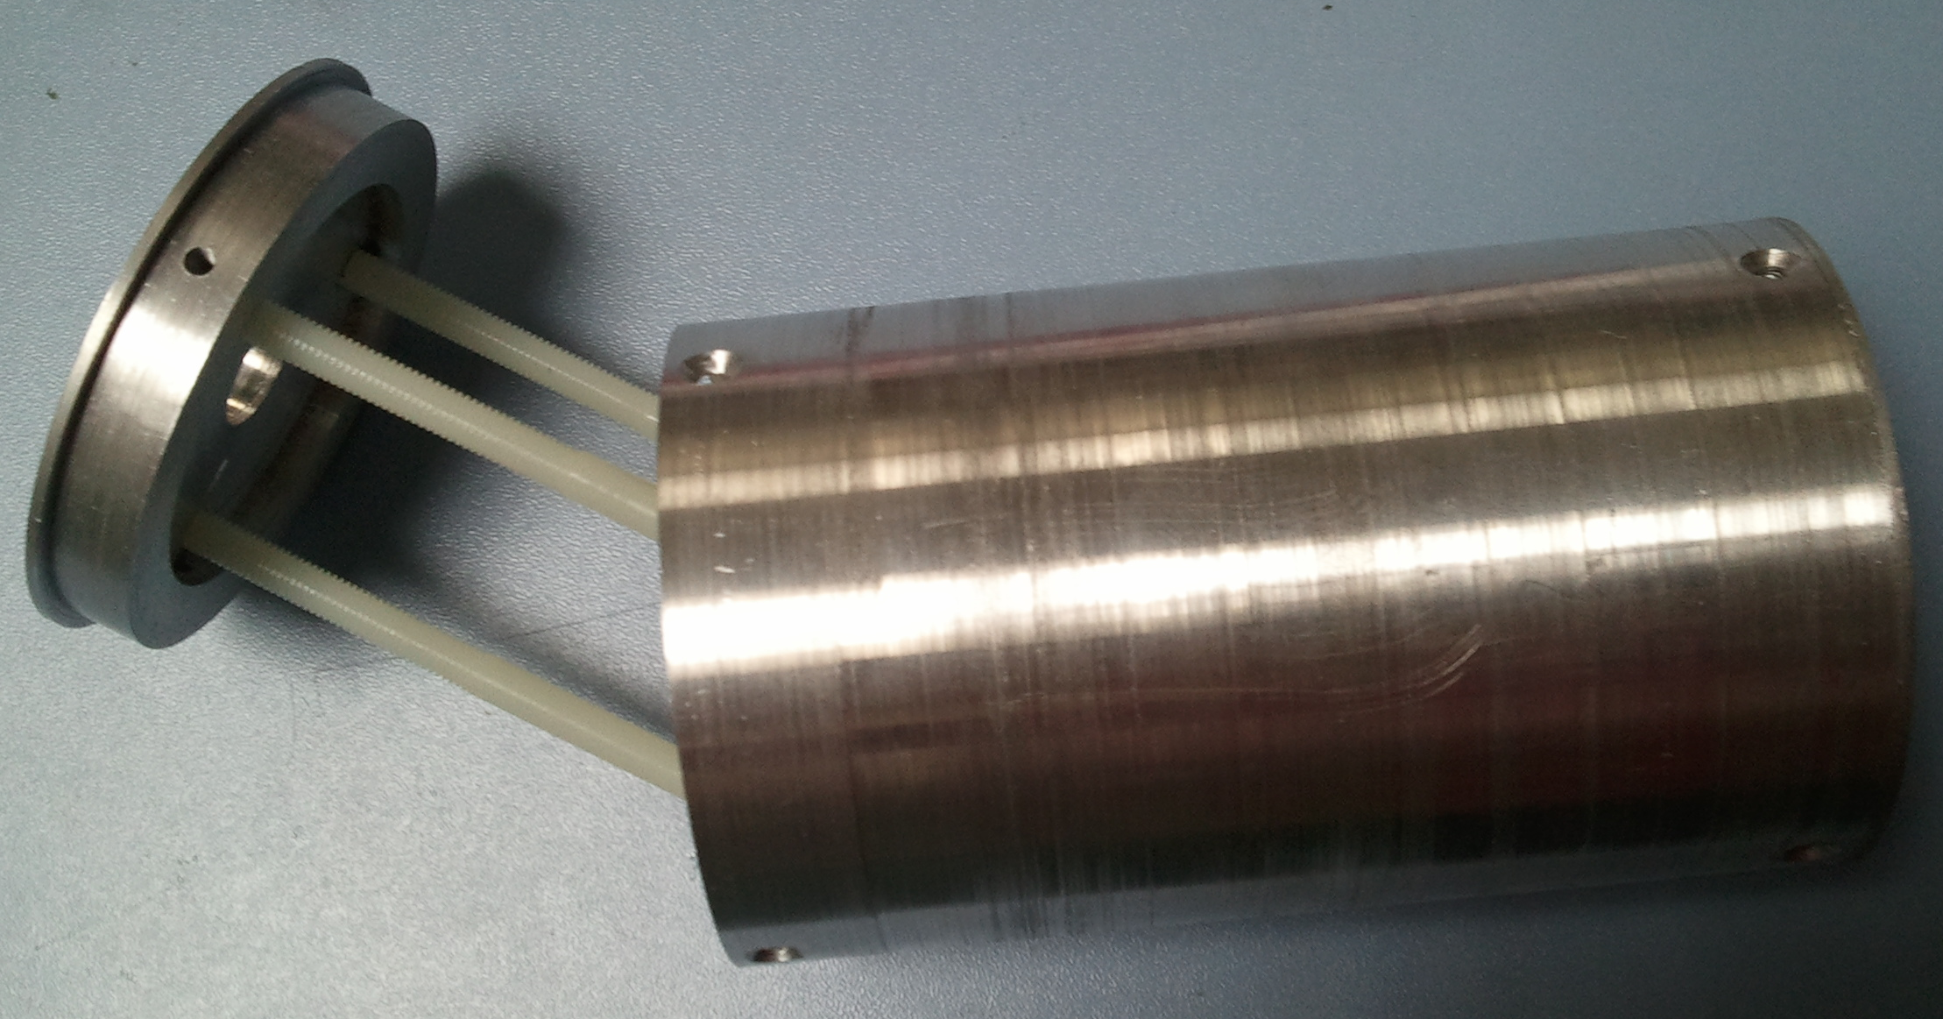
Fig. 2. The aluminum structure and the three nylon rods

The inside part is divided in three levels, from bottom to top: PCB power, electronic board with the microcontroller and electronic card blank where we fixed sensors and servomotor. We wanted to realize an internal structure as neat and organized as possible, in order that components do not move during the descent. Three nylon rods, for reasons of weight, set these three cards in the tube to one of the caps. They are simply screwed to the bottom cap. We can thus assemble and disassemble easily and quickly the CanSat, to reprogram the microcontroller or change one component for example.

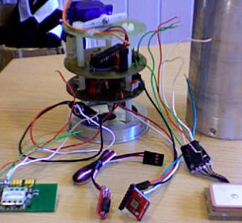
Fig. 3. Internal structure of Sirius

The GPS is placed on the top of the CanSat in a special hole for it. It can so find satellites to localize the CanSat.
The servomotor guides the sail, which is a Parawing 9. In the early months of the conception, we tested a radio-controlled paraglider to understand how the sail reacts in the wind streams, and how the servo must guide the sail, pulling on the strings to control it.

  - Electrical Architecture

As far as the atmospheric measures are concerned, we use a sensor BMP085 (see Fig. 6) which measures both pressure and temperature. It is very convenient because it is very small: it is an essential characteristic because our CanSat mustn’t exceed 33 cL. We also use a humidity sensor.
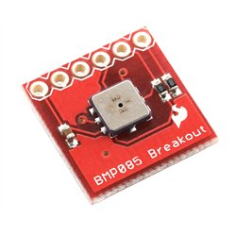
Fig. 6 Pressure Sensor BMP085

Because of the volume of the CanSat, as it has been explained in the previous part, the structure is divided into 3 levels. As a result, the circuit board is separated into two electronic boards: one with a microcontroller, and the other on which sensors and the GPS are connected.
We can see the electronic board with the microcontroller Atmega128, the sensors (pressure, temperature, damp), the GPS, the servomotor and the telemetry system. (see Fig. 4)

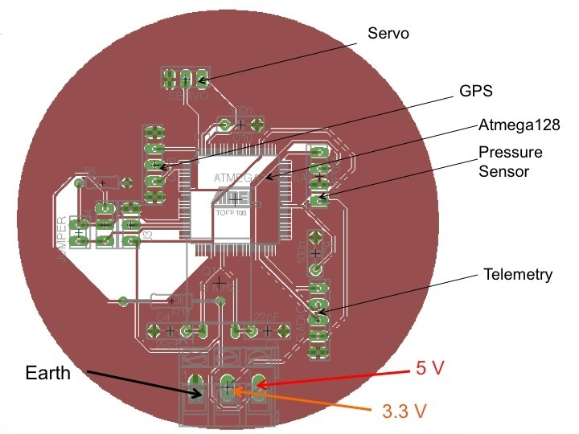
Fig. 4 Electronic board

The second board contains the battery 9V and the converters. The two electronic boards are connected to each other with the ports 5V, 3.3V and the earth. (see Fig. 5)

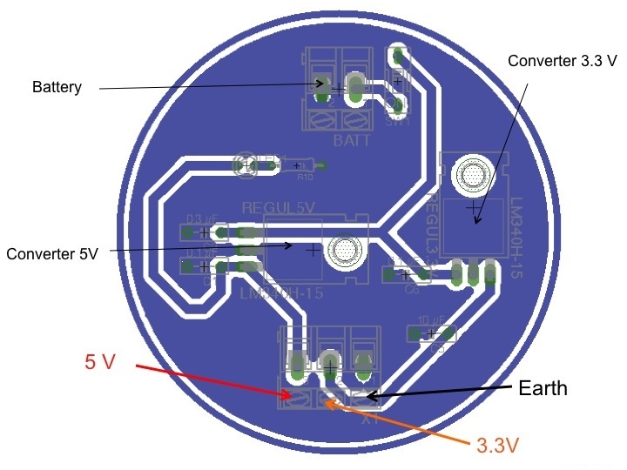
Fig. 5 Electronic board with battery

  - GPS and Servo control

In our Cansat, the paragliding is controlled by a small servo engine. In order to improve the direction of the Cansat, we had to find the most efficient code linking data from GPS and servo control. The GPS chip (EM-406A) provides us with the following datas:
- Longitude and latitude
- Speed in km/h
- Course in degrees
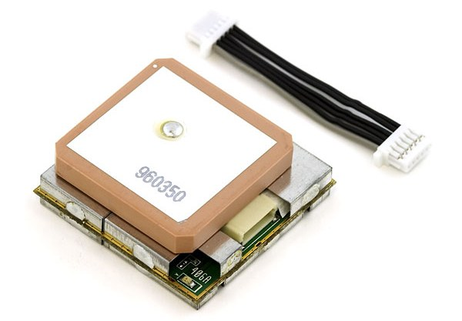
Knowing the positions of the target and the GPS, we can mathematically determine the angle that needs the servo to manage the paragliding towards the target. However, this angle is not the perfect one because of many factors like wind, quality of the paragliding or weight of the Cansat probe. Moreover, we can also not assure that the probe will exactly turn with the angle given to the servo engine. Consequently, we decided to manage the direction through two steps:
1. Get latitude and longitude of the GPS twice to determine the course of the probe and associate it with seven possible angles: 0 degrees for north, 45 for north-east, 90 for east, etc… . We do not use the “course” data from the GPS chip because it is really not relevant into an aluminum structure.
2. Compare the course with the position of the target, and give the right angle to the servo engine. This angle belongs to the same scale of values than previously.
The code is written with Arduino software. We used specific libraries named TinyGPS and Servo which provide us with all the functions needed, as “myservo.write(pos)” which tells servo to go to position in variable ‘pos’, or “gps.get_position” which returns latitude and longitude in degrees.

  - Telemetry

Data collected by the CanSat would be transmitted to ground during flight. The CanSat transmits temperature, pressure, humidity rate and his position to ground. We use a commercial radio transmitter aboard CanSat and a ground station: a modem converts data from a radio frame to a serial link. The reference of the modem we use is ARF43.

- Conclusion

In spite of our lack of technical knowledge at the beginning of the year, and thanks to the help of Emilien and some members of our robotic association, we could have our CanSat built slowly but surely. All the team learnt a lot about how to work together, to have confidence in the other members and also to respect a planning. We do know we should have begun the tests earlier because of the difficulty of the mission “Come-back”: we must test the algorithm of guidance with the GPS, the NASA Parawing and the functionalities of the sensors during the fall of the CanSat. We will test in the last months before the competition.

Acknowledgement

At first, we would like to thank our tutors Mrs. Josephine KOHLENBERG and Mrs. Corinne LE ROUX who allowed us to work on this project and brought us a financial and moral support, as well as the town council of Evry and the association Forum of Telecommunication from Telecom SudParis who provided us aids to help us carrying out our Sirius. Finally, we also want to thank our computer science association Minet and our robotic association Intech for having lent us their technical premises, and given their precious advice.

